ANALYTICS FOR HOSPITALS’HEALTH-CARE DATA
TEAM ID: PNT2022TMID41523
TEAM LEADER
M.SUBA– 621119104020
TEAM MEMBERS
S.PRIYA JENCY - 621119104014
SB.SNEHA - 621119104017
Bachelor of Engineering
In
Computer Science & Engineering

TEAM MEMBER
C.MAGIMAI ILAKKIYA MARY - 621119205004
Bachelor of Technology
In
Information Technology

IDHAYA ENGINEERING COLLEGE FOR WOMEN

TABLE OF CONTENT
INTRODUCTION................................................................................................................................................... 1
1.1 Project Overview ....................................................................................................................................... 4
1.2 Purpose...................................................................................................................................................... 5
LITERATURE SURVEY........................................................................................................................................ 6
2.1 Existing Problem....................................................................................................................................... 9
2.2 Problem Definition .................................................................................................................................... 9
2.3 References................................................................................................................................................. 9
IDEATION AND PROPOSED SOLUTION ........................................................................................................... 11
3.1 Empathy Map............................................................................................................................................. 11
3.2 Ideation and Brainstorming...................................................................................................................... 12
3.3 Proposed Solution .................................................................................................................................... 15
3.4 Problem Solution Fit............................................................................................................................... 17
REQUIREMENT ANALYSIS............................................................................................................................... 18
4.1 Functional Requirements....................................................................................................................... 18
4.2 Non-Functional Requirements............................................................................................................... 19
PROJECT DESIGN............................................................................................................................................. 21
5.1 Dataflow Diagram.................................................................................................................................... 21
5.2 User Stories .............................................................................................................................................. 21
5.2 Technical Architecture ........................................................................................................................... 23

PROJECT PLANNING AND SCHEDULING...................................................................................................... 24
6.1 Sprint Planning & Estimation................................................................................................................. 24
6.2 Sprint Delivery Schedule........................................................................................................................ 25
6.3 Reports for JIRA ..................................................................................................................................... 26
CODING AND SOLUTION.................................................................................................................................. 45
TESTING............................................................................................................................................................. 52
8.1 Test Cases ............................................................................................................................................... 55
8.2 User Acceptance Testing ....................................................................................................................... 55
RESULTS ....................................................................................................................................................... 57
9.1 Performance Metrics............................................................................................................................... 57
PROS AND CONS.............................................................................................................................................. 58
CONCLUSION .................................................................................................................................................... 59
FUTURE WORKS............................................................................................................................................... 60
APPENDIX.......................................................................................................................................................... 61
13.1 Source Code.......................................................................................................................................... 61
13.2 GitHub & Project Demo Link ................................................................................................................ 68

PROJECT REPORT

TEAM ID
  PNT2022TMID41523
PROJECT NAME
  Analytics For Hospitals' Health-Care Data

TEAM MEMBERS:

Team leader : SUBA M

Team member 1 : MAGIMAI ILAKKIYA MARY C

Team member 2 : PRIYA JECY S

Team member 3 : SNEHA SB

CHAPTER 1
1.INTRODUCTION

This project deals with the analytics for hospital's health care data using data analytics. Data analytics (DA) is the process of examining data sets in order to findtrends and draw conclusions about the information they contain. Increasingly, data analytics is done with the aid of specialized systems and software.Data analytics technologies and techniques are widely used in commercial industries to enable organizations to make more•informed business decisions.

1.1.Project Overview

Health care management is the planning, administration, and management of all health care systems, hospitals, and other medical facilities. Health care management roles are crucial to the overall operations of the health care system.
Covid-19 recently, one of the most neglected areas to concentrate on has come under scrutiny due to the pandemic: healthcare management. While data science has many applications in healthcare administration,
If one wants to increase the effectiveness of healthc are management in a hospital, patient length of stay is one crucial indicator to track and forecast. At the time of admission, this metric aids hospitals in identifying patientswho are at high LOS-risk (patients who will stay longer). Once identified, patients at high risk for LOS can have their treatment plans improved to reduce LOS and reduce the risk of infection in staff or visitors. Additionally, prior awareness of LOS might help with planning logistics like room and bed allotment.

1.2.Purpose
In healthcare, data analytics are crucial. According to the Harvard Business School, it aids healthcare organisations in the evaluation and training of practitioners, the identification of scan anomalies, and the forecasting of disease outbreaks. Additionally, data analytics can improve business intelligence and cut expenses for healthcare firms. Hospital data analytics can review patient records and any medication prescribed to identify improper dosages or prescriptions and notify doctors and patients, reducing human error and hospital costs. As a result, better insights are gained, and healthcare professionals are able to make wise decisions.

CHAPTER 2
2.LITERARTURE SURVEY

The healthcare sector is widely considered as one of the most important industries in information technology (Wager 2005). More and more, information technology has been considered as a practice that facilitates healthcare performance through using data and information efficiently within the healthcare sectors. Therefore, Wager et al (2005) said that in order to understand the relation between information technologies and healthcare, we first need to understand what are the technologies used in healthcareThe healthcare sector is widely considered as one of the most important industries in information technology (Wager 2005).
More and more, information technology has been considered as a practice that facilitates healthcare performance through using data and information efficiently within the healthcare sectors. Therefore, Wager et al (2005) said that in order to understand the relation between information technologies and healthcare, we first need to understand what are the technologies used in healthcareThe healthcare sector is widely considered as one of the most important industries in information technology (Wager 2005). More and more, information technology has been considered as a practice that facilitates healthcare performance through using data and information efficiently within the healthcare sectors. Therefore, Wager et al (2005) said that in order to understand the relation between information technologies and healthcare, we first need to understand what are the technologies used in healthcare The healthcare sector is widely considered as one of the most important industries in information technology. More and more, information technology has been considered as a practice that facilitates healthcare performance through using data and information efficiently within the healthcare sectors.
Therefore, Wager et al(2005) said that in order to understand the relation between information technologies and healthcare, we first need to understand what are the technologies used in healthcareIn the mid-80,’s information technology changed the healthcare industry and brought many benefits when they used microcomputers, which were a small in shape, fast and very powerful for that time. Moreover, this allowed hospitals to develop clinical applications for various medical care settings. As a result, hospitals started to purchase and adopt information systems in the healthcare industries, and after that, challenges began to emerge when professionals tried to integrate data among these systems (Wager et al 2005).

The healthcare industry has generated large amount of data generated from record keeping, compliance and patient related data. In today’s digital world, it is mandatory that these data should be digitized. To improve the quality of healthcare by minimizing the costs, it’s necessary that large volume of data generated should be analysed effectively to answer new challenges. Similarly government also generates petabytes of data every day. It requires a technology that helps to perform a real time analysis on the enormous data set. This will help the government to provide value added services to the citizens. Big data analytics helps in discovering valuable decisions by understanding the data patterns and the relationship between them with the help of machine learning Algorithms (1).This paper provides an overview of big data analytics in healthcare and government systems. It describes about big data generated by these systems, data characteristics, security issues in handling big data and how big data analytics helps to gain a meaningful insight on these data set.
The healthcare industry has generated large amount of data generated from record keeping, compliance and patient related data. In today’s digital world, it is mandatory that these data should be digitized. To improve the quality of healthcare by minimizing the costs, it’s necessary that large volume of data generated should be analysed effectively to answer new challenges. Similarly government also generates petabytes of data every day. It requires a technology that helps to perform a real time analysis on the enormous data set. This will help the government to provide value added services to the citizens. data analytics helps in discovering valuable decisions by understanding the data patterns and the relationship between them with the help of machine learning algorithms. This paper provides an overview of data analytics in healthcare and government systems. It describes about data generated by these systems, data characteristics, security issues in handling data and how big data analytics helps to gain a meaningful insight on these data set.

TITLE :Historical Review of Health Policy Making AUTHOR : Ravi Duggal

Health policy making and health planning in India is not a post-independence phenomenon. In fact, the most comprehensive health policy and plan document ever prepared in India was on the eve of Independence in 1946. This was the ‘Health Survey and Development Committee Report’ popularly referred to as the Bhore Committee. This Committee prepared a detailed plan of a National Health Service for the country, which would provide a universal coverage to the entire population free of charges through a comprehensive state run salaried health service.
Such a well-studied and minutely documented plan has not as yet been prepared in Independent India. Health services in India today in terms of accessibility are as inadequate and underdeveloped as they were during the time of the Bhore Committee. The analysis of the health situation by the Bhore Committee in the early forties would hold good if a similar enquiry were undertaken today, over half a century later. Instead of the National Health Service that the Bhore Committee had envisaged, which would be available to one and all irrespective of their ability to pay, further commodification of health care services took place strengthening the operation of market forces in this sector. The enclave pattern of development of the health sector continues even today - the poor, the villagers, women and other underprivileged sections of society, in other words the majority, still do not have access to affordable basic health care of any credible quality ventricular tachycardia(3.4%)which includes cardiogenic shock (1.4%)to hypotension (0.3%).

Disadvantages
To put more Extensive effort into building these predictive models.

2.1.EXISTING PROBLEM

- The already existing model istrained with minimal parameters
- Low accuracy in prediction
- No feature extractiondone
- High complexity

2.2.PROBLEM STATEMENT AND DEFINITION

• The aim is to accurately predictthe Length of Stay for each patienton case by case basis so that the Hospitals can use this information for optimal resource allocation and better functioning.
• The length of stay is divided into 11 different classes ranging from 0- 10 days to more than 100 days.

2.3.REFERENCES

[1] Data analytics for the sustainable use of resources in hospitals: Predicting the length of stay for patients with chronic diseases
httP-s://www.sciencedirect.com/science/article/P-iilS0378720619301594

[2] Robust Length of Stay Prediction Model for Indoor Patients

httP-s://www.researchgate.net/P-ublication/355174497 Robust Length of Stay : Predicti on Model _for_Indoor_Patients
[3] Predicting length of stay in hospitals intensive care unit using general admission features http-s://www.sciencedirect.com/science/article/P-iilS2090447921001349

[4] ] Using Data Analytics to Improve Hospital Quality Performance

htt ps:// jou rnals.lww.com/ jhmonline/ Fulltext/ 2020/08000/Using_Data Analytics_to Improve Hospital_Qualtiy.9.aspx

[5] Big Data analytics on Diabetic Retinopathy Study (DRS) on real-time data set identifying survival time and length of stay https://www.sciencedirect.com/science/article/pii/S1877050916304926

CHAPTER 3

3.IDEATION & PROPOSED SOLUTION

3.1.EMPATHY MAP CANVAS

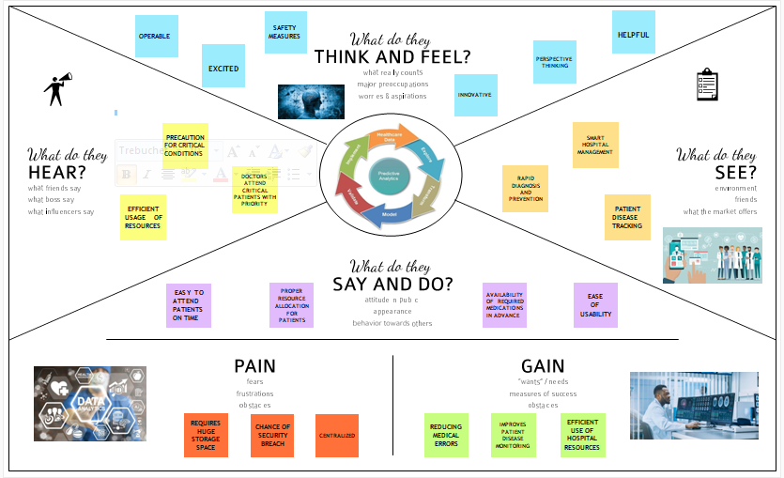

3.2.IDEATION & BRAINSTORMING

Brainstorm & Idea Prioritization Template:

Reference: https://www.mural.co/templates/empathy-map-canvas

Step-1: Team Gathering, Collaboration and Select the Problem Statement

Step-2: Brainstorm, Idea Listing and Groupin

Step-3: Idea Prioritization

3.3.PROPOSED SOLUTION

Project team shall fill the following information in proposed solution template.

  S.No.
  Parameter
  Description
1
  ProblemStatement(Problemtobesolved)
  During the covid-19 pandemic, we have faced one of thedifficulttimesofourlife.Everyoneseekstosurvivefromthegreat disaster. At the time of pandemic, noone get to knowabout which hospital has vacant beds(free beds) to admitthemselves or others infected by covid. This situation madethedeathratehigher.
2
  Idea/Solutiondescription
  Predictive analytics can create patient journey dashboards anddisease trajectories that helps us to know about the patient’speriodofstay.Itimproveseffectiveallocationofbedsandotherresources,treatmentdelivery,improvesefficiencies,andsoon.
3 | Novelty/Uniqueness | Healthcare data frequently resides in several locations. TheCollected data should be stored in central system(like centralizedstorage). This data becomes accessible and usable when it iscombinedintoasingle,centralsystem,suchasanenterprisedatawarehouse (EDW). Uniqueness of our project is that we can ableto use data for different things such as which medicine is moreeffective and for understanding behavioural pattern of particulardisease.
4 | SocialImpact/CustomerSatisfaction | effectiveuseofresourceEnhanced diagnosisImprovedTreatment  enhancing the overall quality oftreatmentandlifeofpatients
5 | BusinessModel(RevenueModel) | With the gathered data, redirecting the patients to particularhospitalbasedonthevacancy,leadingretailersusedmethodslikemarket-basket analysis to discover insights about consumerpurchase behaviour and used these insights to optimize thephysical store experience, target relevant ads and streamline thesupplychain, amongotherstrategicinitiatives.

6 | ScalabilityoftheSolution | A variety of institutions must store, evaluate, and take action onthe massive amounts of data being produced by the health caresectorasitexpandsquickly.Indiaisavast,culturallyvariednationwith a sizable population that is increasingly able to accesscentralisedhealthcareservices.

3.4.PROBLEM SOLUTION FIT

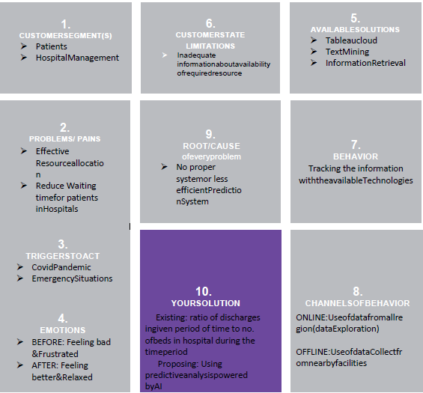

CHAPTER 4
4.REQUIREMENT ANALYSIS
4.1.FUNCTIONAL REQUIREMENT

Following are the functional requirements of the proposed solution.
  FR No.
  Functional Requirement (Epic)
  Sub Requirement (Story / Sub-Task)
FR-1
  User Registration
  Registration through Form Registration
  through Gmail
FR-2
  User Confirmation
  Confirmation via Email Confirmation
  via Message
FR-3
  Interoperability
  Dashboard helps to share the patient’s information
  interoperable to the hospitals in timely manner.
FR-4
  Accuracy
  Dashboard helps predict the patient’s Health risks
  accurately based on LOS (Length of Stay).
FR-5
  Compliance
  The compliance of a dashboard is like to use very
  interactively in real time by the hospitals
FR-6
  Concise
  These dashboards are clear, intuitive, and customizable
  and interactive in manner.

4.2. Non-functional Requirement

Following are the non-functional requirements of the proposed solution.
FR NO
  Non-Functional Requirement
  Description
NFR-1
  Usability
  This Dashboards are designed to offer a comprehensive overview of patient’s LOS, and do so through the use of data visualization tools like charts
  and graphs.
NFR-2
  Security
  The Dashboard helps to indicate the current threat level to the Hospitals; an indication of events and incidents that have occurred; a record of authentication errors; unauthorized access
NFR-3 | Reliability | This dashboard will be consistent and reliable to the  users and helps the user to use in effective, efficient and reliable manner.
NFR-4 | Performance | This dashboard can scan the backend users and analyzing the frequency in which they visit the dashboard helps understand how useful and helpful  the data displayed is for tasks.
NFR-5 | Availability | The dashboard can available to meet user’s demand in timely manner and it is also helps to provide  necessary information to the user’s dataset
NFR-6 | Scalability | The layers used in the dashboard are a hosted feature  layer, feature layer view, or hosted tile layer.

CHAPTER 5
5.PROJECT DESIGN
5.1.DATA FLOW DIAGRAM

A Data Flow Diagram (DFD) is a traditional visual representation of the information flows within a system. A neat and clear DFD can depict the right amount of the system requirement graphically. It shows how data enters and leaves the system, what changes the information, and where data is stored.
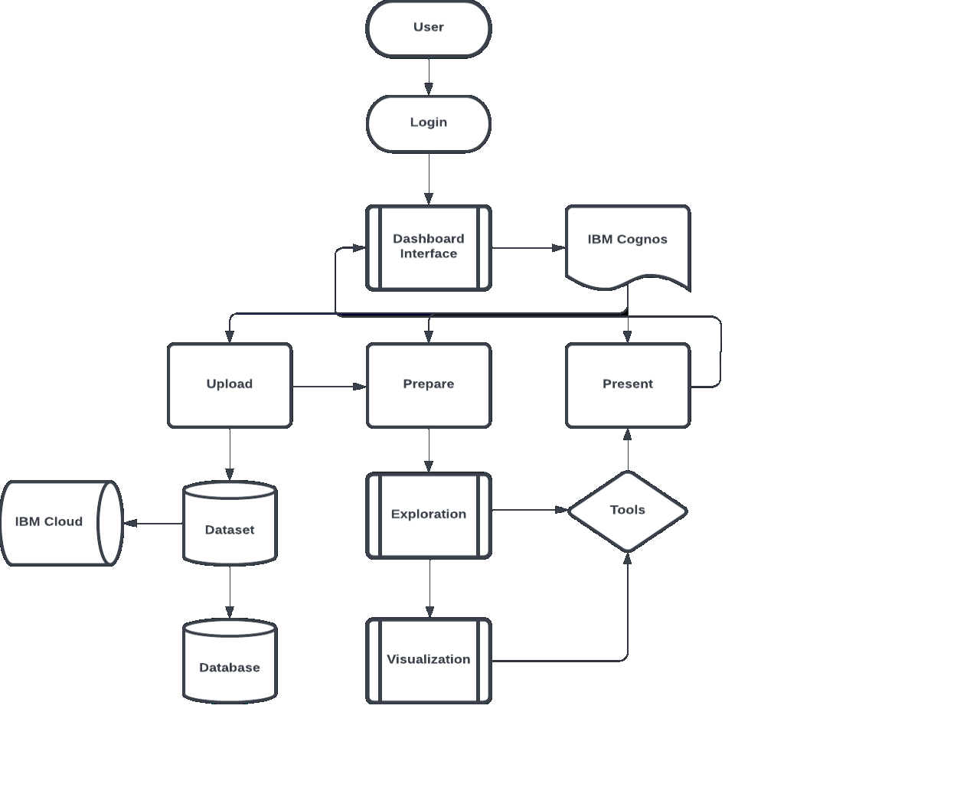

5.2.User Stories
Use the below template to list all the user stories for the product.
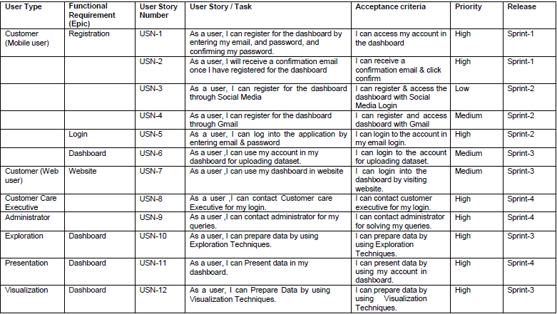

SOLUTION AND TECHNICAL ARCHITECTURE
5.3.SOLUTION ARCHITECTURE

ETL PROCESS (DATAINTEGRATIONPROCESS)

CHAPTER 6

6.PROJECT PLANNING AND SCHEDULING
6.1.Sprint Delivery Plan I

Project Planning Phase

Project Planning Template (Product Backlog, Sprint Planning, Stories, Story points).
Product Backlog, Sprint Schedule, and Estimation
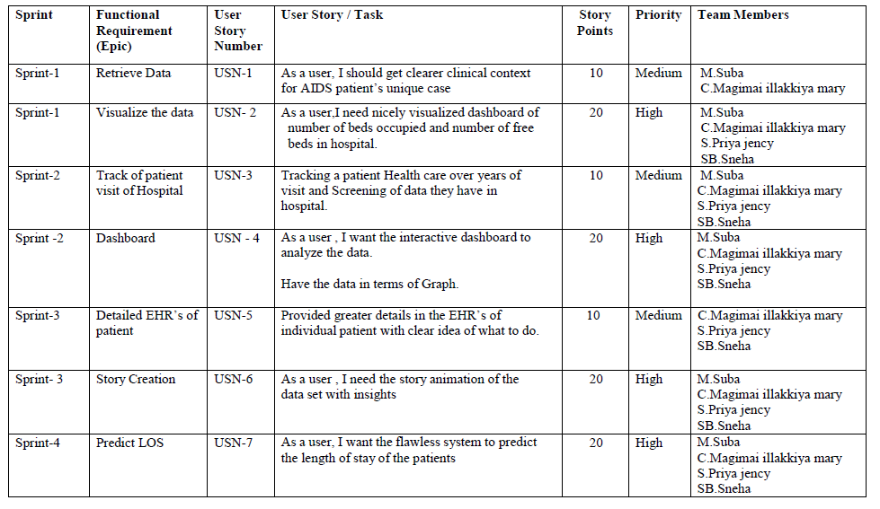

6.2.SPRINT DELIVERY SCHEDULE
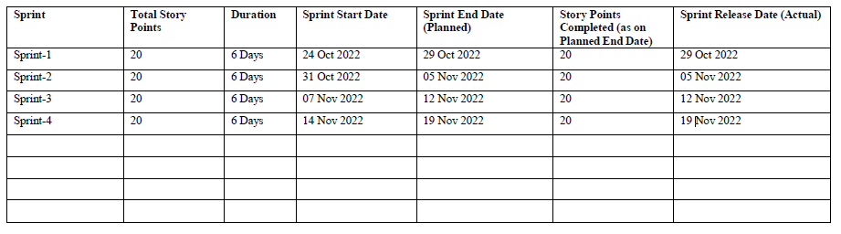

Project Planning Phase

Milestones & Tasks
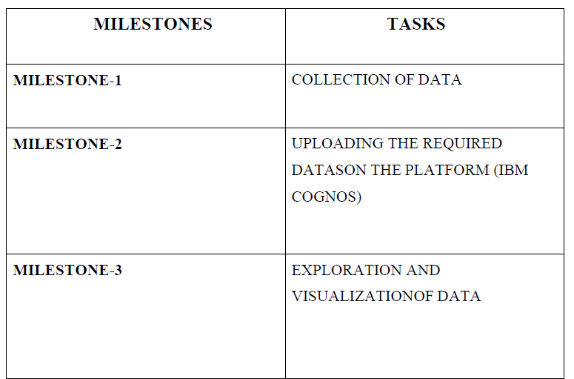
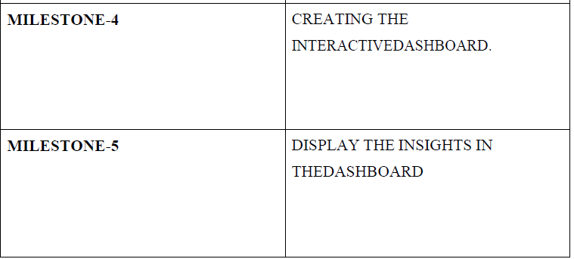
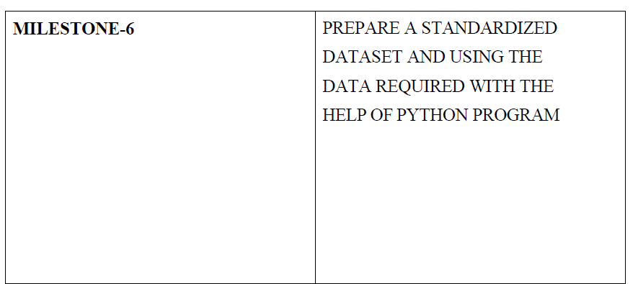
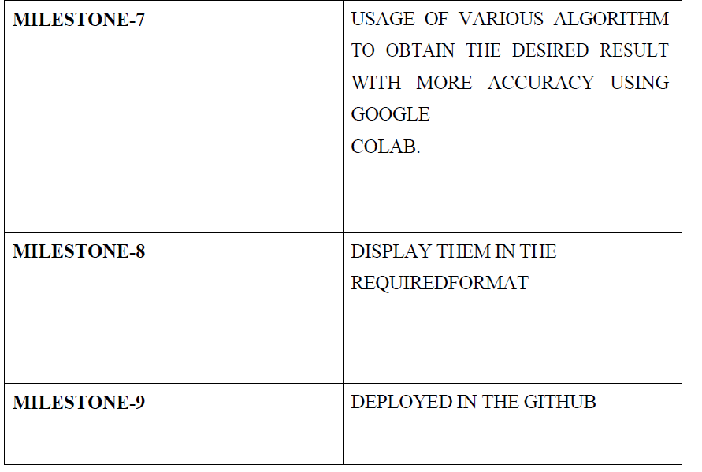

PROJECT DEVELOPMENT PHASE

Sprint Delivery Plan I
Importing Data Sets of Analytics for Hospitals Health Care Data Using Cognos Analysis:
USN-1:
As a User I can enter the details of the patients working in our organization of the details.
Uploading the dataset of test_data.csv and train_data.csv file to IBM Cognos Analytics.

Data Analysis

Analysation of health data:

FIVE TYPES OF HEALTHCARE DATA ANALYTICS:

Exploratory Data Analysis
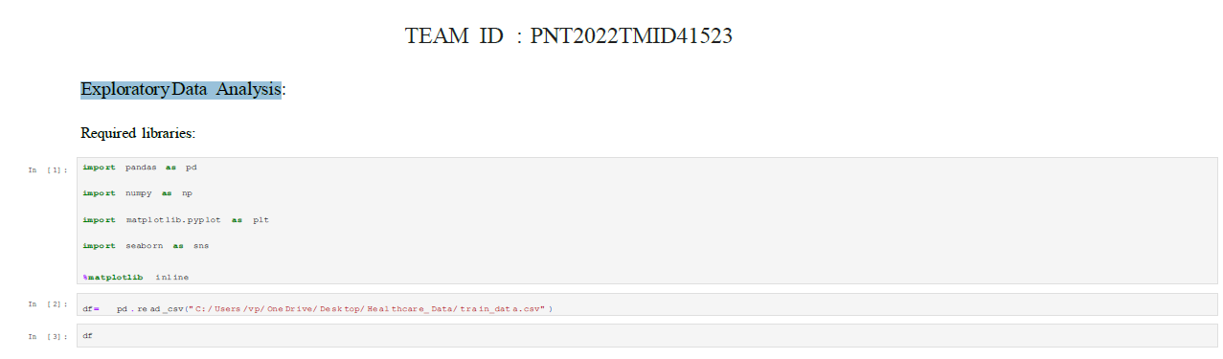
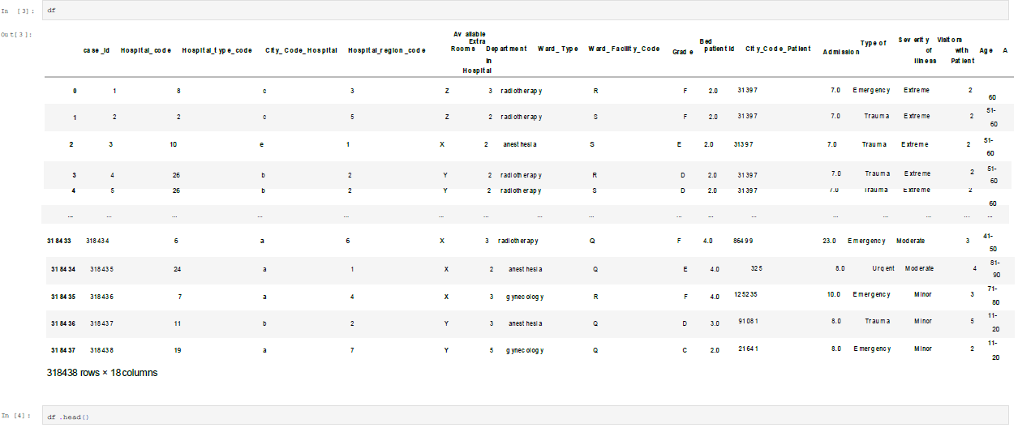
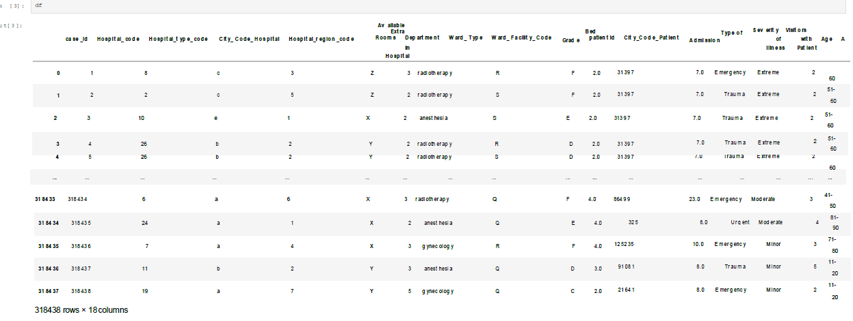
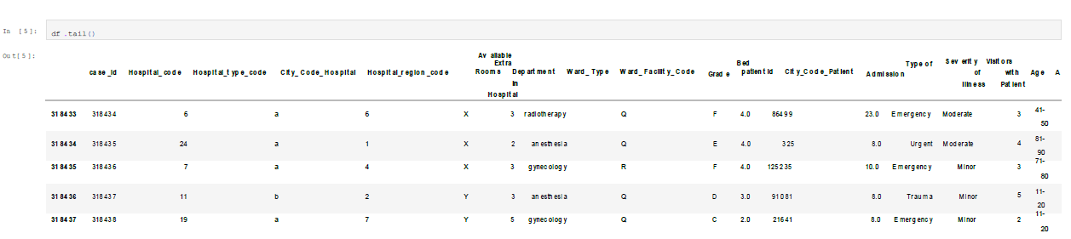
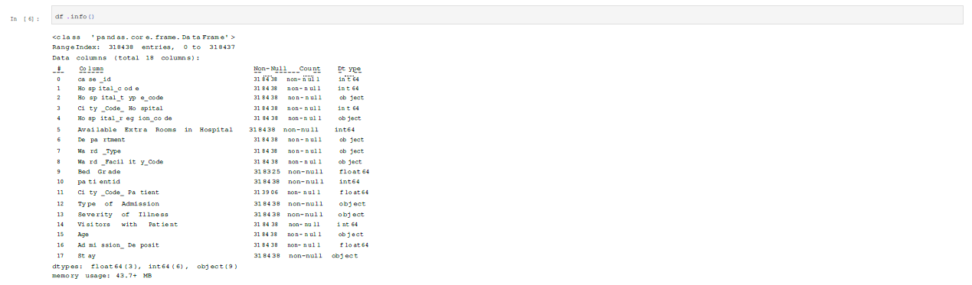
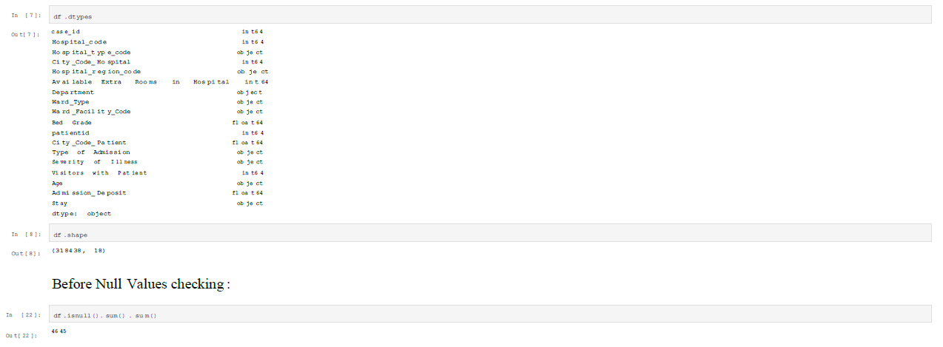
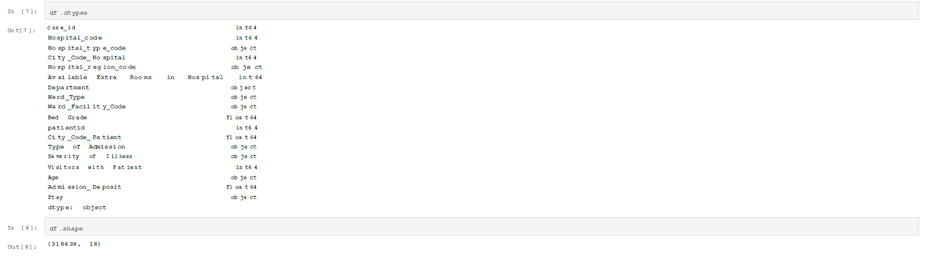
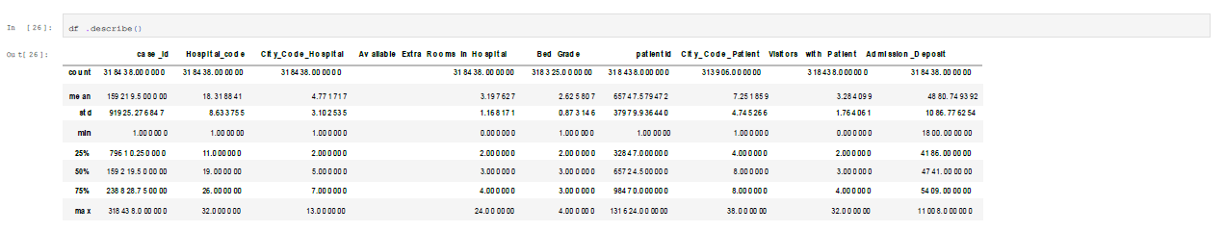
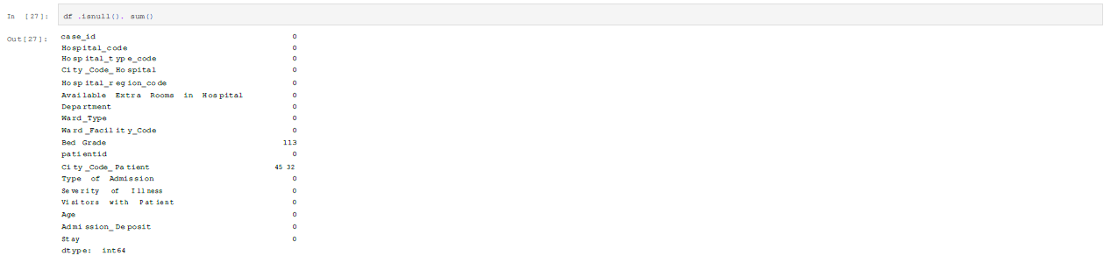
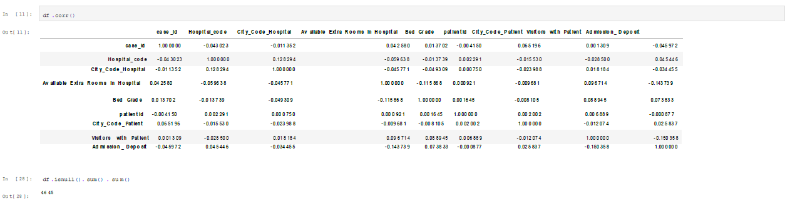
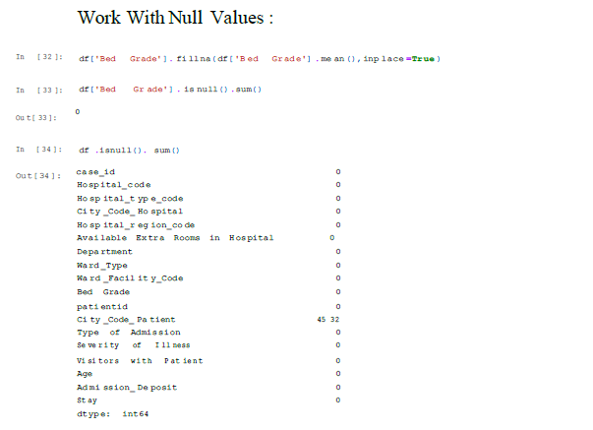
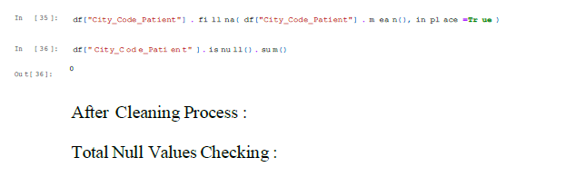
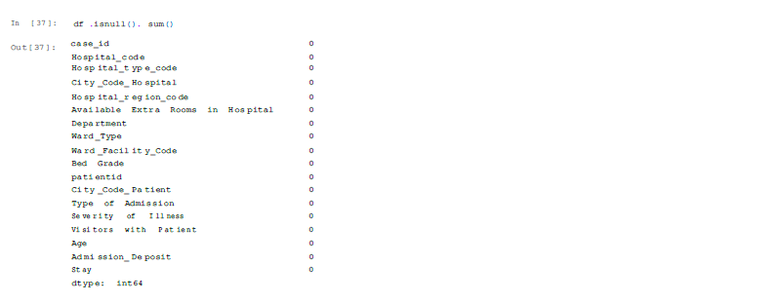
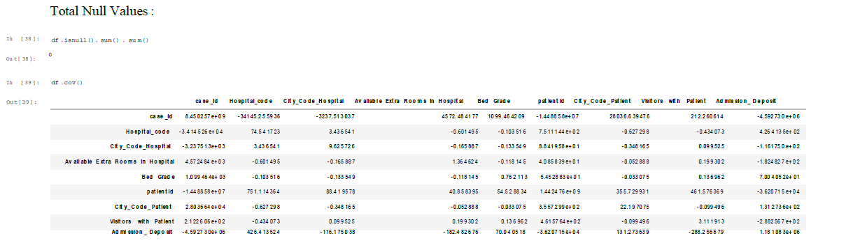
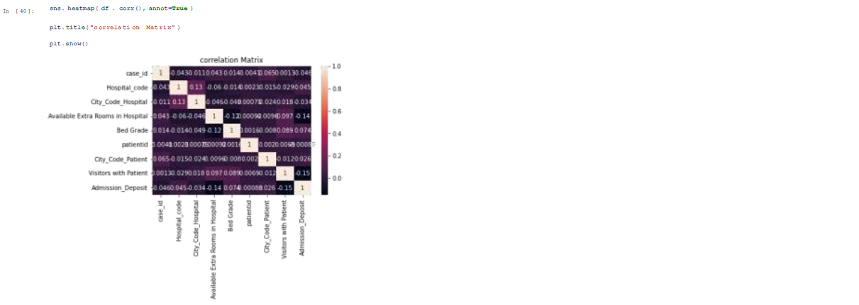
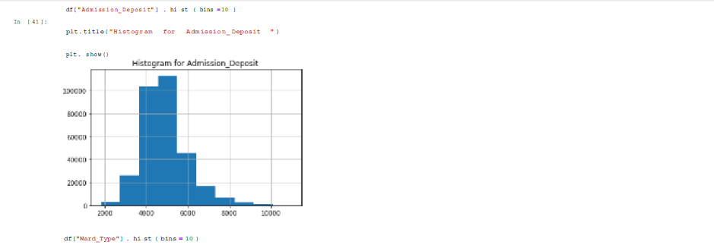
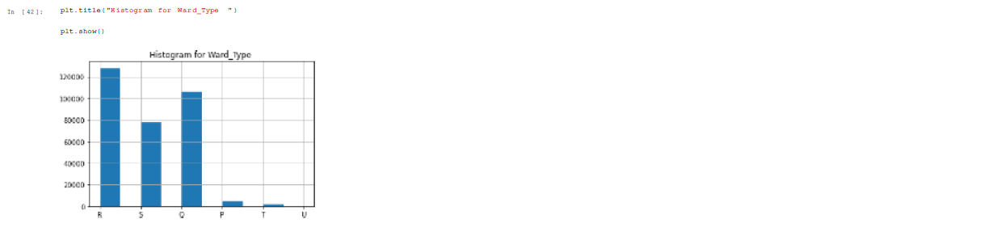

Sprint Delivery Plan II

Cleaning, Exploring data and creating model of Analytics for Hospitals Health Care Data Using Cognos Analysis:

USN-4,5

• As an Analyst I can create a Exploratory data analysis to identify the important factors of a patient data set.

• As a Data analyst, I create a predicted model by also preparing story card with using explored data.
• Create an Data Exploration of the dataset of test_data.csv and train_data.csv file to IBM Cognos Analytics first.

Creating Relationships

Ward_Type

Visitors with patient

Create a Visualization type using test_data.csv IBM Cognos Analytics:
Visitors with Patient by Ward_Type colored by Ward_Type

- Across all values of Ward_Type and Ward_Type, the sum of Visitors with Patient is over 450 thousand.
- For Visitors with Patient, the most significant values of Ward_Type are R, Q, and S, whose respective Visitors with Patient values add up to over 438 thousand, or 97.4 % of the total
- The summed values of Visitors with Patient range from 8 to over 171 thousand.
- Visitors with Patient is unusually high when the combinations of Ward_Type and Ward_Type are R and R and Q and Q.
- Visitors with Patient is unusually high when Ward_Type is R and Q
Available Extra Rooms in Hospital by Department:
- The total number of results for Available Extra Rooms in Hospital, across all departments, is over 137 thousand.
- The most common value of Department is gynecology, occurring over 107 thousand times, which is 78.2 % of the total.
- The count is unusually high when Department is gynecology.

Department by Severity of Illness with points for Available Extra Rooms in Hospital .

CHAPTER 7
SOURCE CODE:
HOME PAGE_;_

Index.html
<!DOCTYPE html>
<html lang="en">
<head>
<title>Data Analytics</title>
<meta charset="utf-8">
<meta name="viewport" content="width=device-width, initial-scale=1">
<link rel="stylesheet" href="https://maxcdn.bootstrapcdn.com/bootstrap/3.4.1/css/bootstrap.min.css">
<script src="https://ajax.googleapis.com/ajax/libs/jquery/3.6.0/jquery.min.js"></script>
<script src="https://maxcdn.bootstrapcdn.com/bootstrap/3.4.1/js/bootstrap.min.js"></script>
</head>
<body>

<nav class="navbar navbar-inverse">
<div class="container-fluid">
<div class="navbar-header">
<a class="navbar-brand" href="about.html">Analytics for Hospitals' Health-Care Data</a>
</div>
<ul class="nav navbar-nav">
<li class="active"><a href="#">Home</a></li>

<li><a href="dashboard.html">Dashboard</a></li>
<li><a href="report.html">Report</a></li>
<li><a href="story.html">Story</a></li>
</ul>
</div>
</nav>

<div class="jumbotron">
<center> <h4><i><b>Team ID : PNT2022TMID41523 </b></i></h4></center>

</div>
<table class="table table-bordered">

<tbody>
<tr>
<td>Team Leader</td>
<td>Suba M</td>

</tr>
<tr>
<td>Team member</td>
<td>Magimai ilakkiya mary C</td>

</tr>
<tr>
<td>Team member</td>
<td>priya jency S</td>

</tr>
<tr>
<td>Team member</td>
<td>Sneha SB</td>

</tr>

</tbody>
</table>
</body>
</html>
ABOUT PAGE:
About.html
<!DOCTYPE html>
<html lang="en">
<head>
<title>Data Analytics</title>
<meta charset="utf-8">
<meta name="viewport" content="width=device-width, initial-scale=1">
<link rel="stylesheet" href="https://maxcdn.bootstrapcdn.com/bootstrap/3.4.1/css/bootstrap.min.css">
<script src="https://ajax.googleapis.com/ajax/libs/jquery/3.6.0/jquery.min.js"></script>
<script src="https://maxcdn.bootstrapcdn.com/bootstrap/3.4.1/js/bootstrap.min.js"></script>
</head>
<body>

<nav class="navbar navbar-inverse">
<div class="container-fluid">
<div class="navbar-header">
<a class="navbar-brand" href="#">Analytics for Hospitals' Health-Care Data</a>
</div>
<ul class="nav navbar-nav">
<li class="active"><a href="index.html">Home</a></li>
<li><a href="dashboard.html">Dashboard</a></li>
<li><a href="report.html">Report</a></li>
<li><a href="story.html">Story</a></li>
</ul>
</div>
</nav>

<div class="container">
<b>Analytics For Hospitals' Health-Care Data</b>
<br><br>

Recent Covid-19 Pandemic has raised alarms over one of the most overlooked areas to focus: HealthcareManagement.
While healthcare management has various use cases for using data science, patient length of stay is one critical parameter to observe and predict if one wants to improve the efficiency of the healthcare management in a hospital.
This parameter helps hospitals to identify patients of high LOS-risk (patients who will stay longer) at the time of admission. Once identified, patients with high LOS risk can have their treatment plan optimized to minimize LOS and lower the chance of staff/visitor infection. Also, prior knowledge of LOS can aid in logistics such as room and bed allocation planning.
Suppose you have been hired as Data Scientist of Health Man a not for profit organization dedicated to manage the functioning of Hospitals in a professional and optimal manner.
<br><br>
<br><br>
<b>Goal:</b>
<br><br>
The goal is to accurately predict the Length of Stay for each patient on case by case basis so that the Hospitals can use this information for optimal resource allocation and better functioning. The length of stay is divided into 11 different classes ranging from 0-10 days to more than 100 days.

<br>

<br><br>

<b>Technical Architecture:</b>
<br>
<br><br>
<img src="Technical_architecture.png">

</div>
</body>
</html>
Dashboard.html
<!DOCTYPE html>
<html lang="en">
<head>
<title>Data Analytics</title>
<meta charset="utf-8">
<meta name="viewport" content="width=device-width, initial-scale=1">
<link rel="stylesheet" href="https://maxcdn.bootstrapcdn.com/bootstrap/3.4.1/css/bootstrap.min.css">
<script src="https://ajax.googleapis.com/ajax/libs/jquery/3.6.0/jquery.min.js"></script>
<script src="https://maxcdn.bootstrapcdn.com/bootstrap/3.4.1/js/bootstrap.min.js"></script>

</head>
<body>

<nav class="navbar navbar-inverse ">
<div class="container-fluid">
<div class="navbar-header">
<a class="navbar-brand" href="#">Analytics for Hospitals' Health-Care Data</a>
</div>
<ul class="nav navbar-nav">
<li><a href="index.html">Home</a></li>
<li class="active"><a href="#">Dashboard</a></li>
<li><a href="report.html">Report</a></li>
<li><a href="story.html">Story</a></li>
</ul>
</div>
</nav>

<div class="container">
<iframe src="https://us3.ca.analytics.ibm.com/bi/?perspective=dashboard&amp;pathRef=.my_folders%2Fsprint3&amp;closeWindowOnLastView=true&amp;ui_appbar=false&amp;ui_navbar=false&amp;shareMode=embedded&amp;action=view&amp;mode=dashboard&amp;subView=model000001848bea4a5e_00000000" width="1000" height="900" frameborder="0" gesture="media" allow="encrypted-media" allowfullscreen=""></iframe>
</div>

</body>
</html>

OUTPUT:
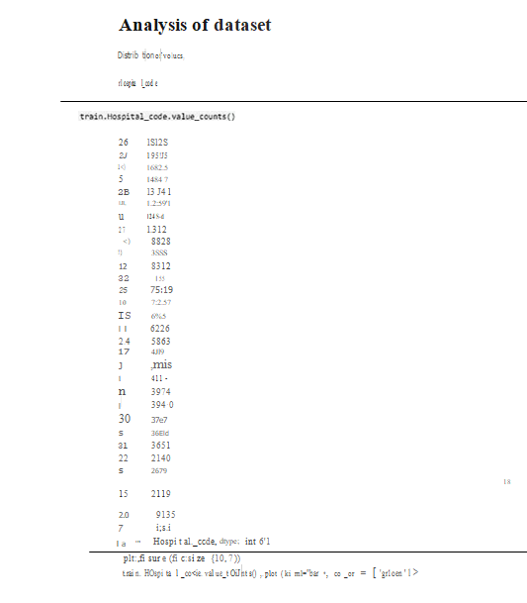
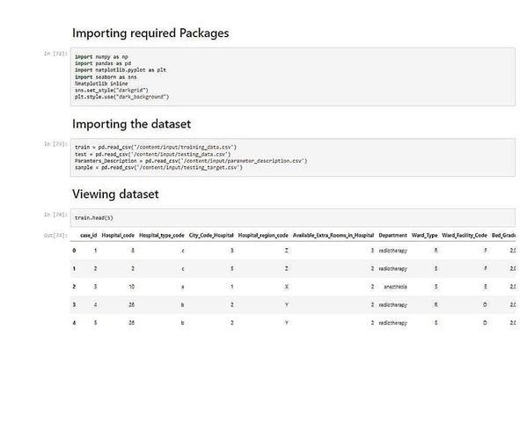
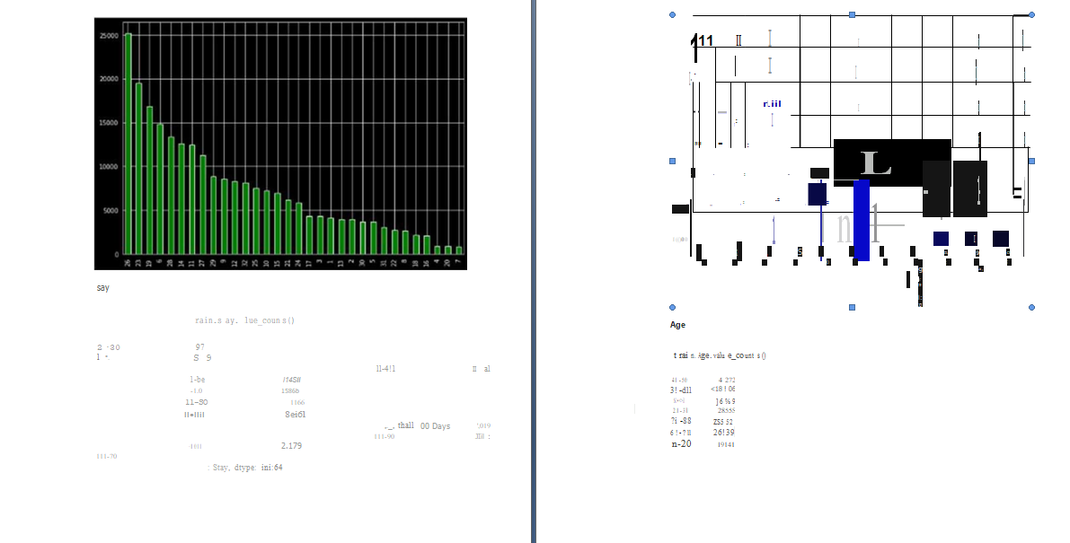
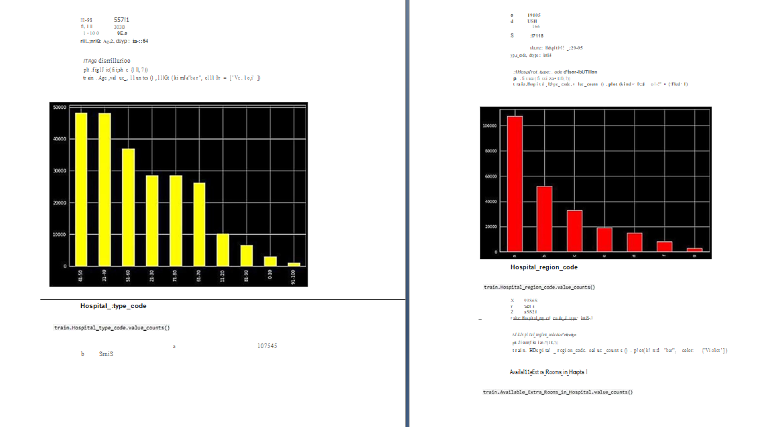
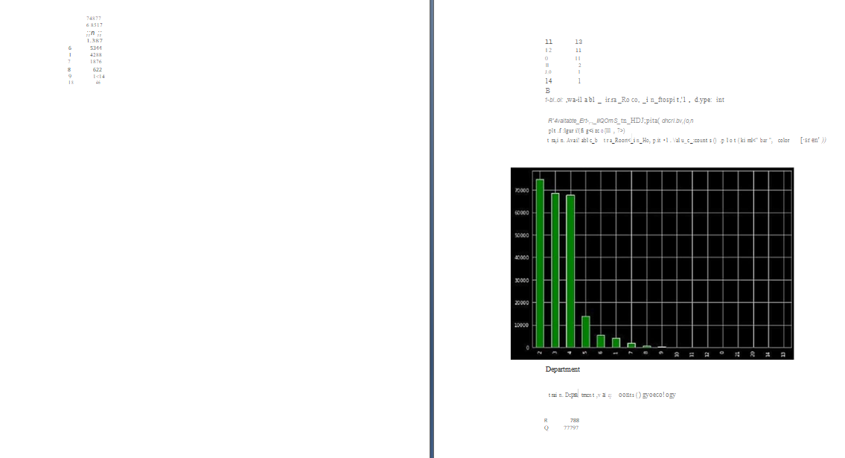

8.CHATER TESTING
8.1.TEST CASES
- verify user is able to see home page
- verify user is able to see dashboard page
- verify user is able to naivigate to story page
- verify filters are working
8.2 USER ACCEPTANCE TESTING
1.Purpose of Document
The purpose of this document is to briefly explain the test coverage and open issuesof the [ProductName] project at the time of the release to User Acceptance Testing (UAT).
Defect Analysis
This report showsthe number of resolved or closed bugs at each severity level, and how they were resolved.
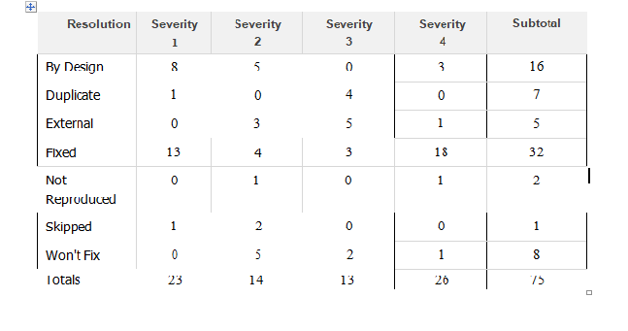

3.Test Case Analysis
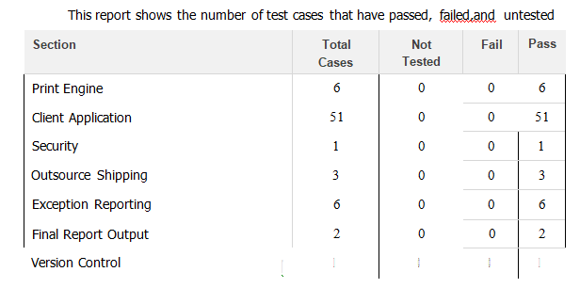

CHAPTER 9
9.RESULT
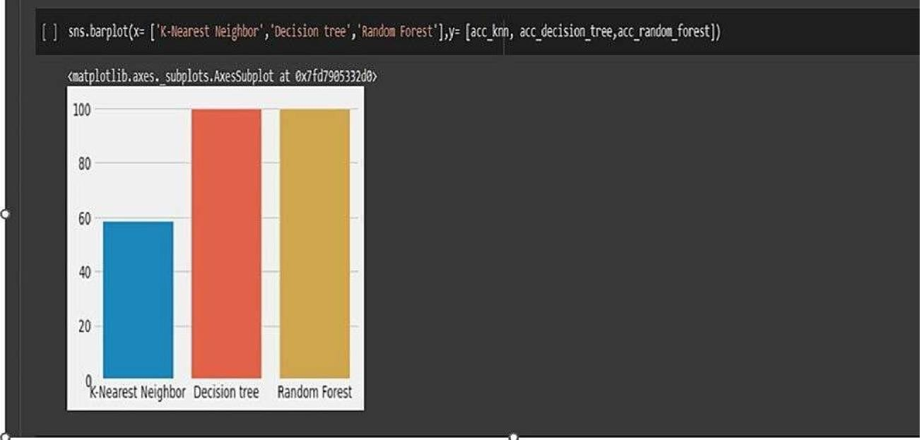

9.1.PERFORMANCE METRICS:

10.PROS AND CONS:
One of the major drawbacks in the application of big data in healthcare industry is the issue of lack of privacy. Application of big data technologies involves monitoring of patient's data, tracking of medical inventoryand assets, organizing collected data, and visualization of data on the dashboard and the reports. So visualization of sensitive medical data especially that of the patients creates negative impression of big data as it violets privacy

CHAPTER 11
11.CONCLUSION
The impact of data analytics in healthcare has already made a substantial difference in the abiley of healthcare providers to offer patients high-quality car in an efficient, cost-effective manner. However, the role of data analytica in improving patientoutcomes and bethcare processes continues to grow and expand as more types of data become allcle and new tools are developed that make the results of the analytics clear and easy for healthcare professionals to access.
Realing the potential of data analytics to transform the healthcare industry begins by understanding how the technology can be applied to addres heathcare providers challenges Including stat recitment and the utilization operational efficiencies, and enhanced patent experiences Pre-centred that depends on knowing what patients want and need. Data analytics holds the hity to unlockingthis vital Information.

12.FUTURE SCOPE:
Artificial Intelligence (AI) will play a significant role in data analytics in healthcare for the next decade. For example, the field of AI-enabled clinical decision support is just emerging. This type of support can compare patients who fit similar profileswithin a system,then it can alert doctorsto trends in data that may havebeen overlooked. The use of big data in healthcare will include testing for drug interactions that small studies are unlikely to catch and prevent patients from takingharmful drug combinations.

Decisions made by physicians, like what test or treatments to give a particular patient, makeup 80-90% of all healthcare spending, so using artificial intelligence to make more educated decisions will bring down healthcare costs. It's crucial to have informed leaders at the vanguard of these innovations in healthcare.

CHAPTER 13
13.APPENDIX
SOURCE CODE:
HOME PAGE_;_

Index.html
<!DOCTYPE html>
<html lang="en">
<head>
<title>Data Analytics</title>
<meta charset="utf-8">
<meta name="viewport" content="width=device-width, initial-scale=1">
<link rel="stylesheet" href="https://maxcdn.bootstrapcdn.com/bootstrap/3.4.1/css/bootstrap.min.css">
<script src="https://ajax.googleapis.com/ajax/libs/jquery/3.6.0/jquery.min.js"></script>
<script src="https://maxcdn.bootstrapcdn.com/bootstrap/3.4.1/js/bootstrap.min.js"></script>
</head>
<body>

<nav class="navbar navbar-inverse">
<div class="container-fluid">
<div class="navbar-header">
<a class="navbar-brand" href="about.html">Analytics for Hospitals' Health-Care Data</a>
</div>
<ul class="nav navbar-nav">
<li class="active"><a href="#">Home</a></li>

<li><a href="dashboard.html">Dashboard</a></li>
<li><a href="report.html">Report</a></li>
<li><a href="story.html">Story</a></li>
</ul>
</div>
</nav>

<div class="jumbotron">
<center> <h4><i><b>Team ID : PNT2022TMID41523 </b></i></h4></center>

</div>
<table class="table table-bordered">

<tbody>
<tr>
<td>Team Leader</td>
<td>Suba M</td>

</tr>
<tr>
<td>Team member</td>
<td>Magimai ilakkiya mary C</td>

</tr>
<tr>
<td>Team member</td>
<td>priya jency S</td>

</tr>
<tr>
<td>Team member</td>
<td>Sneha SB</td>

</tr>

</tbody>
</table>
</body>
</html>
ABOUT PAGE:
About.html
<!DOCTYPE html>
<html lang="en">
<head>
<title>Data Analytics</title>
<meta charset="utf-8">
<meta name="viewport" content="width=device-width, initial-scale=1">
<link rel="stylesheet" href="https://maxcdn.bootstrapcdn.com/bootstrap/3.4.1/css/bootstrap.min.css">
<script src="https://ajax.googleapis.com/ajax/libs/jquery/3.6.0/jquery.min.js"></script>
<script src="https://maxcdn.bootstrapcdn.com/bootstrap/3.4.1/js/bootstrap.min.js"></script>
</head>
<body>

<nav class="navbar navbar-inverse">
<div class="container-fluid">
<div class="navbar-header">
<a class="navbar-brand" href="#">Analytics for Hospitals' Health-Care Data</a>
</div>
<ul class="nav navbar-nav">
<li class="active"><a href="index.html">Home</a></li>
<li><a href="dashboard.html">Dashboard</a></li>
<li><a href="report.html">Report</a></li>
<li><a href="story.html">Story</a></li>
</ul>
</div>
</nav>

<div class="container">
<b>Analytics For Hospitals' Health-Care Data</b>
<br><br>

Recent Covid-19 Pandemic has raised alarms over one of the most overlooked areas to focus: HealthcareManagement.
While healthcare management has various use cases for using data science, patient length of stay is one critical parameter to observe and predict if one wants to improve the efficiency of the healthcare management in a hospital.
This parameter helps hospitals to identify patients of high LOS-risk (patients who will stay longer) at the time of admission. Once identified, patients with high LOS risk can have their treatment plan optimized to minimize LOS and lower the chance of staff/visitor infection. Also, prior knowledge of LOS can aid in logistics such as room and bed allocation planning.
Suppose you have been hired as Data Scientist of Health Man a not for profit organization dedicated to manage the functioning of Hospitals in a professional and optimal manner.
<br><br>
<br><br>
<b>Goal:</b>
<br><br>
The goal is to accurately predict the Length of Stay for each patient on case by case basis so that the Hospitals can use this information for optimal resource allocation and better functioning. The length of stay is divided into 11 different classes ranging from 0-10 days to more than 100 days.

<br>

<br><br>

<b>Technical Architecture:</b>
<br>
<br><br>
<img src="Technical_architecture.png">

</div>
</body>
</html>
Dashboard.html
<!DOCTYPE html>
<html lang="en">
<head>
<title>Data Analytics</title>
<meta charset="utf-8">
<meta name="viewport" content="width=device-width, initial-scale=1">
<link rel="stylesheet" href="https://maxcdn.bootstrapcdn.com/bootstrap/3.4.1/css/bootstrap.min.css">
<script src="https://ajax.googleapis.com/ajax/libs/jquery/3.6.0/jquery.min.js"></script>
<script src="https://maxcdn.bootstrapcdn.com/bootstrap/3.4.1/js/bootstrap.min.js"></script>

</head>
<body>

<nav class="navbar navbar-inverse ">
<div class="container-fluid">
<div class="navbar-header">
<a class="navbar-brand" href="#">Analytics for Hospitals' Health-Care Data</a>
</div>
<ul class="nav navbar-nav">
<li><a href="index.html">Home</a></li>
<li class="active"><a href="#">Dashboard</a></li>
<li><a href="report.html">Report</a></li>
<li><a href="story.html">Story</a></li>
</ul>
</div>
</nav>

<div class="container">
<iframe src="https://us3.ca.analytics.ibm.com/bi/?perspective=dashboard&amp;pathRef=.my_folders%2Fsprint3&amp;closeWindowOnLastView=true&amp;ui_appbar=false&amp;ui_navbar=false&amp;shareMode=embedded&amp;action=view&amp;mode=dashboard&amp;subView=model000001848bea4a5e_00000000" width="1000" height="900" frameborder="0" gesture="media" allow="encrypted-media" allowfullscreen=""></iframe>
</div>

</body>
</html>

DEMO LINK:
https://youtu.be/Rgg04FdYY1A

Links GitHub
https://github.com/IBM-EPBL/IBM-Project-18081-1659678980

